WHAT IS A SPEECH PATHOLOGIST?
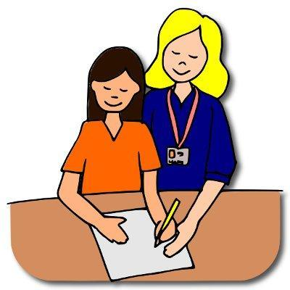

WHAT IS A SPEECH-LANGUAGE PATHOLOGIST?
A speech pathologist (aka speech-language pathologist, SLP, speech therapist) provides therapy for disorders of articulation, language, processing, voice, fluency, pragmatics, hearing, oral-motor and feeding/swallowing.

WHAT DOES A SPEECH PATHOLOGIST DO?
A speech pathologist serves many functions. Not only do they diagnose and treat speech and language disorders, they may also act as a consultant to educational, medical, and other professional groups; conduct research to develop diagnostic and remedial techniques; serve as a consultant to classroom teachers to incorporate speech and language development activities into daily schedules; and instruct staff in the use of specialized equipment and techniques for use within the classroom to assist with the development of all students' speech and language skills.
Below, you will find a list of definitions related to speech and language. These are designed to inform you of the different areas related to speech-language pathology and provide you insight regarding the area(s) that your child's therapy may be focusing on.

Articulation - the production of specific speech sounds (i.e., a child who says wabbit for rabbit or has a lisp)

Language - composed of many different areas, including: syntax (grammar), semantics (word meaning, vocabulary), morphology (the organization of individual words) and pragmatics (social language). Can also be broken down into expressive language (how we use language) and receptive language (how language is understood).

Voice - the loudness, pitch, and quality (i.e., hoarseness) of how we speak

Fluency - also known as stuttering, fluency is the variation in rhythm, phrasing, stress, inflection, and speed of speech without inappropriate pauses, interjections, or fragmentation

Oral-motor - the structure and coordination of the articulators, including lips, teeth, tongue, jaw and cheeks.

Language Processing - processing that is not dependent on acoustic signals (like auditory processing). There are other modes we use to receive, perceive, analyze, store, retrieve, formulate, and produce language. For example, we can use sign language, body language, and writing to transmit and comprehend messages. The modes of communication are not dependent on direct auditory input and can be developed without it.

Auditory Processing - what we do with what we hear. Central Auditory Processing Disorders (CAPD) are deficits in the formation and processing of auditory signals NOT attributed to impaired hearing, sensitivity or intellectual impairment. It can involve delays in a child's ability to: attend, discriminate, and identify acoustic signals; transform and continuously transmit information through both the peripheral and central nervous systems; filter, sort and combine information at appropriate perceptual and conceptual levels; store and retrieve information efficiently; restore, using phonological, semantic, syntactic, and pragmatic knowledge; and attach meaning to a stream of acoustic signals.

